Nalongsone Danddank Student ID : 14958950 StarID: jf3893pd

Email: [nalongsone.danddank@my.metrostate.edu](mailto:nalongsone.danddank@my.metrostate.edu)\

**ICS 432 - 01 — Distributed and Cloud Computing Fall 2021**

**Assignment #2 :** Load Balancing and Auto Scaling

Exercise 1: Implementing a scalable AWS infrastructure to host a web site.

**Homework report screen-shot #1:**

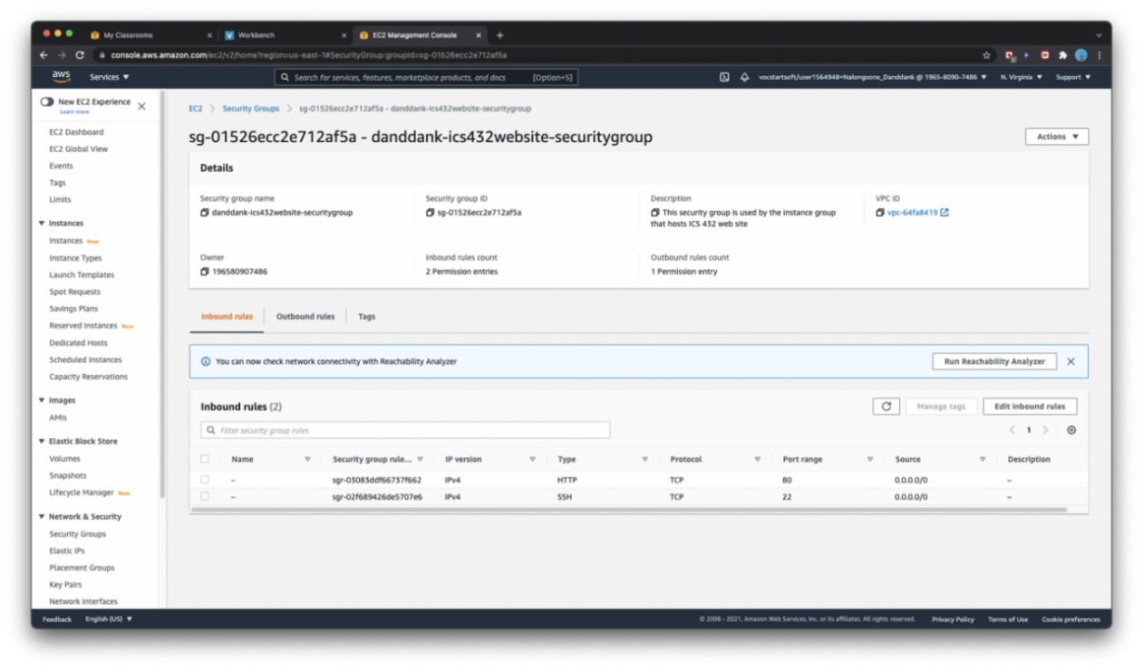

**Homework report screen-shot #2:**

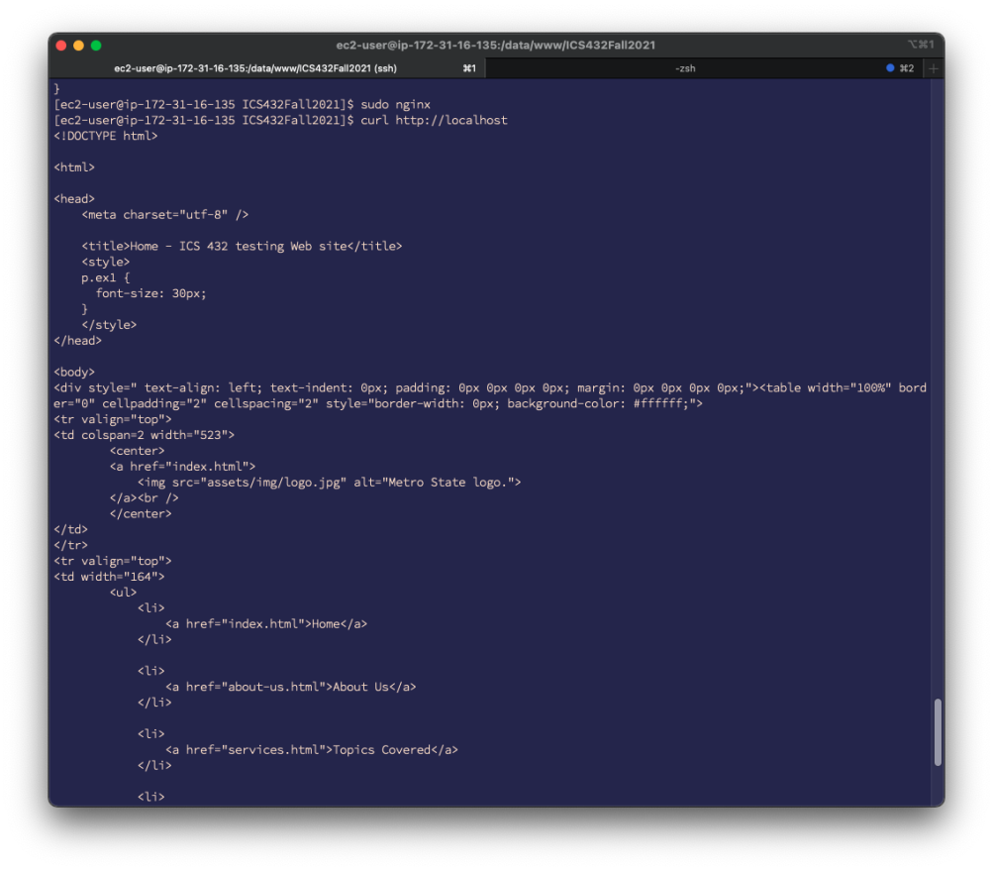

**Homework report screen-shot #3:**

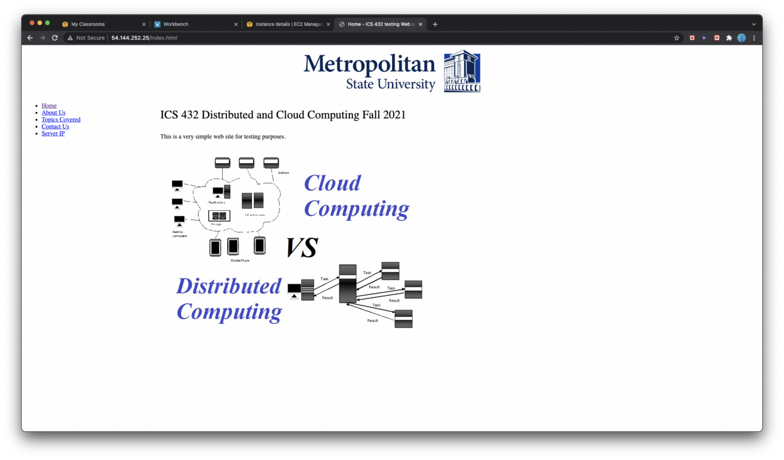

**Homework report screen-shot #4:**

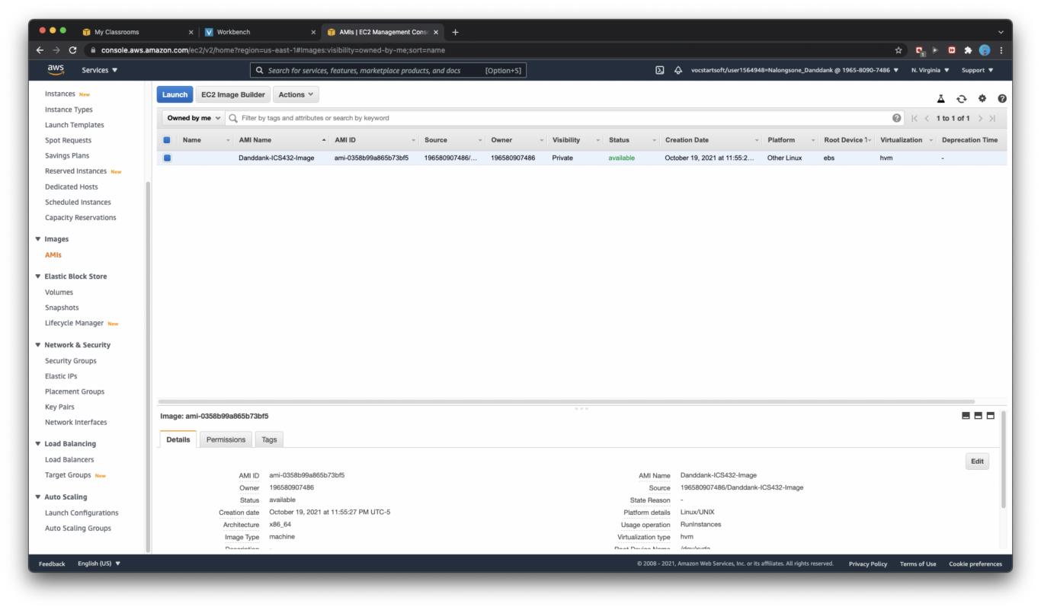

**Homework report screen-shot #5:**

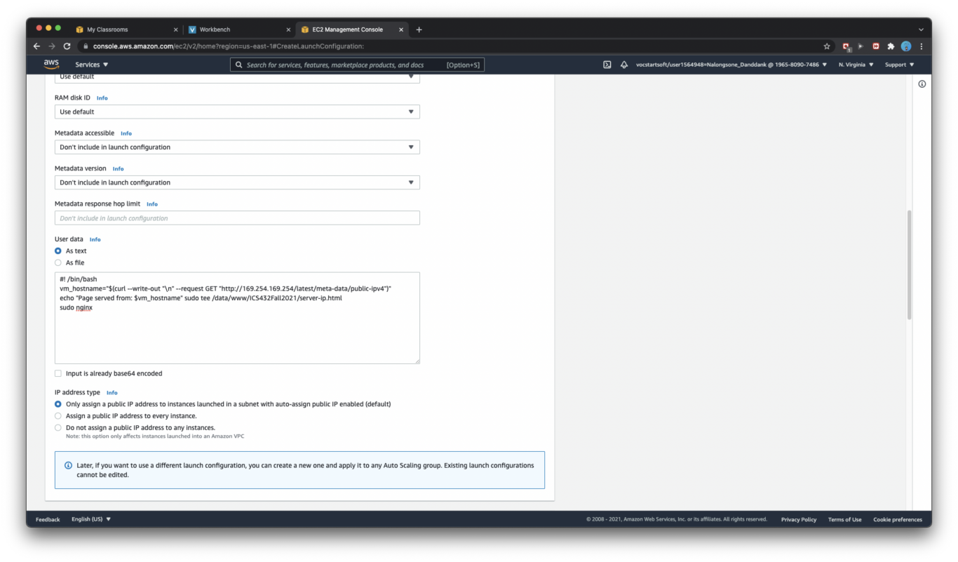

**Homework report screen-shot #6:**

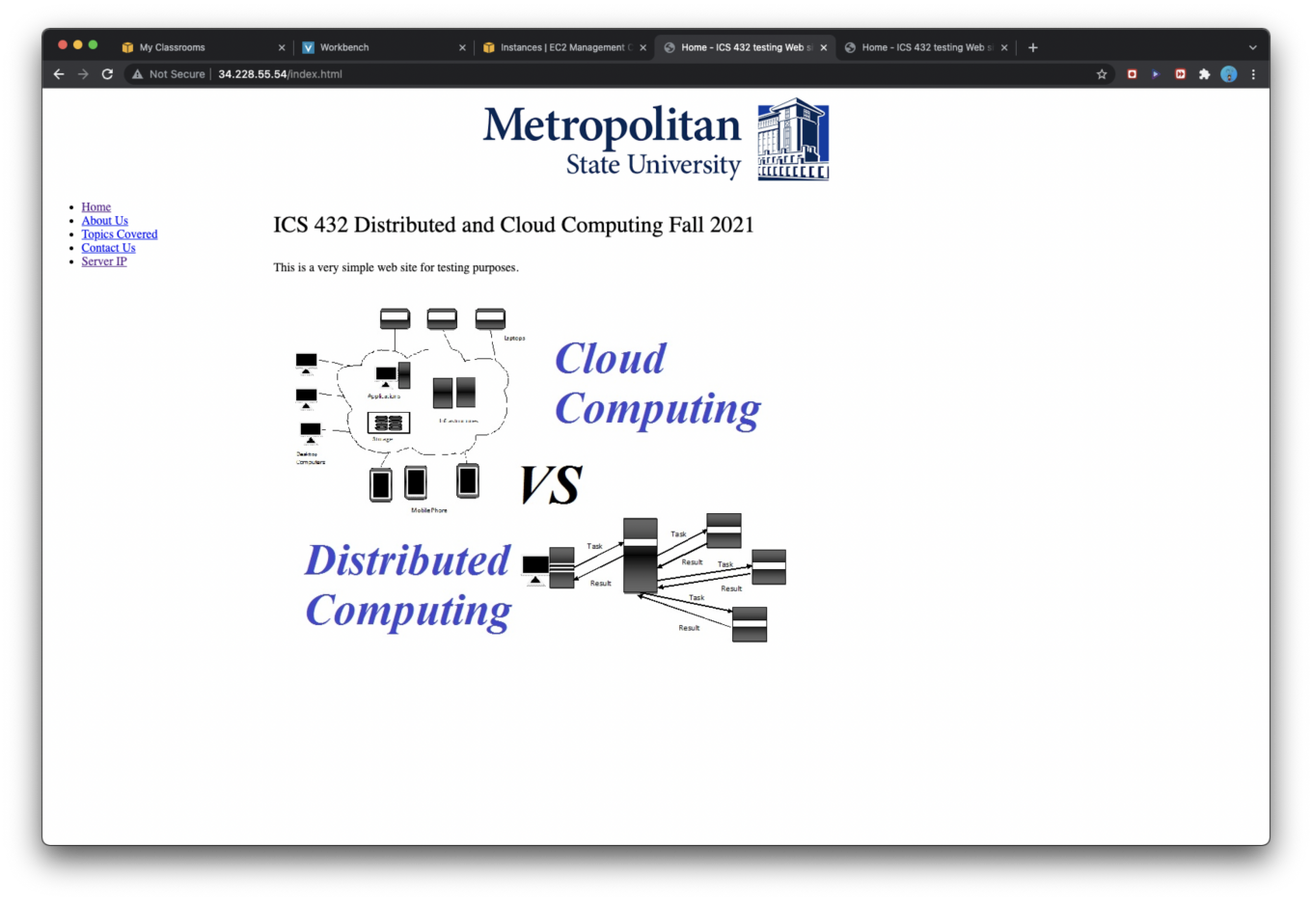

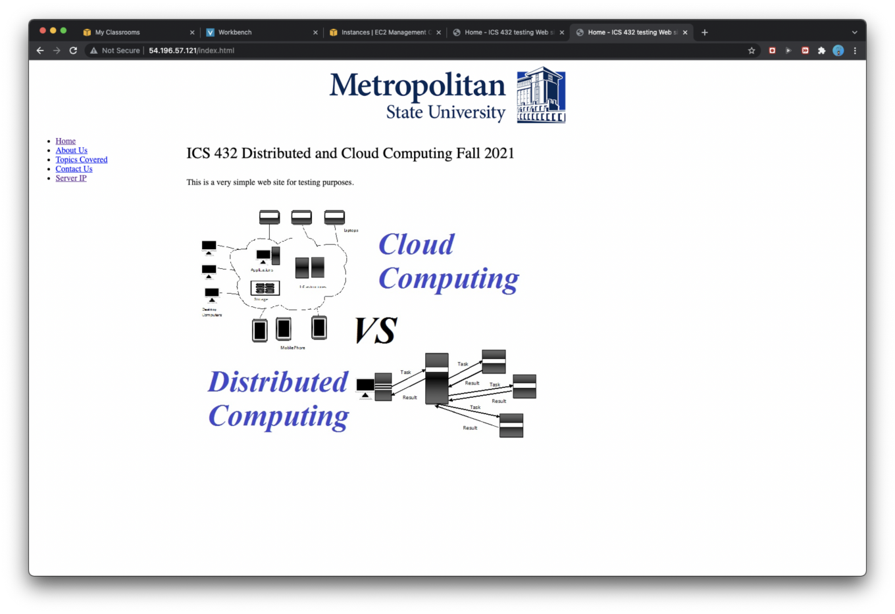

**Homework report screen-shot #7:**

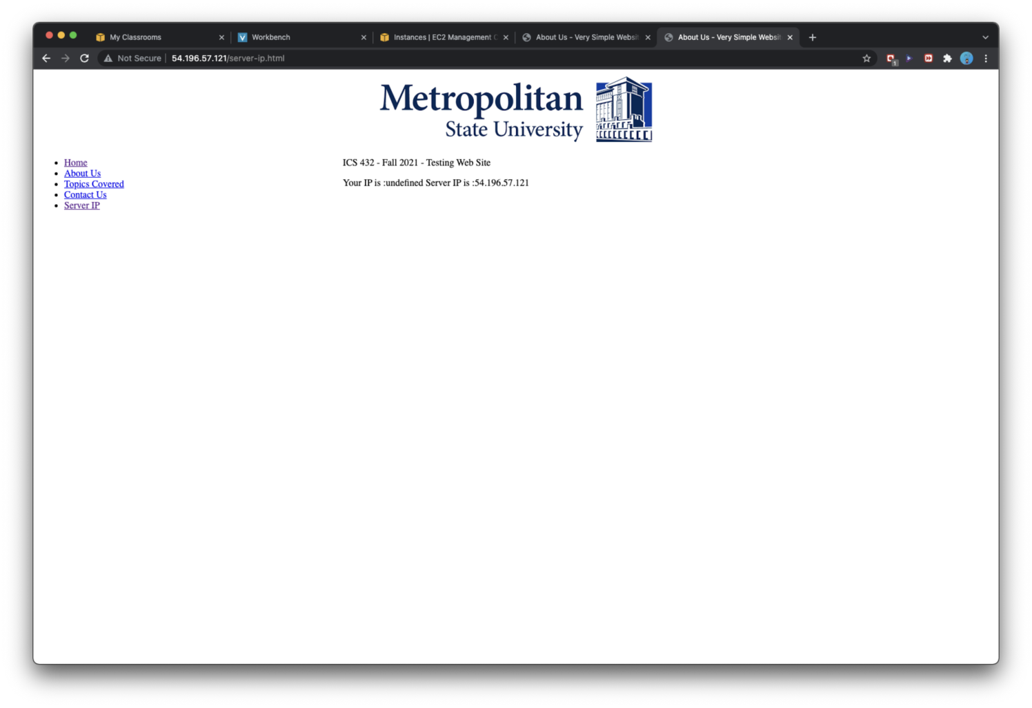

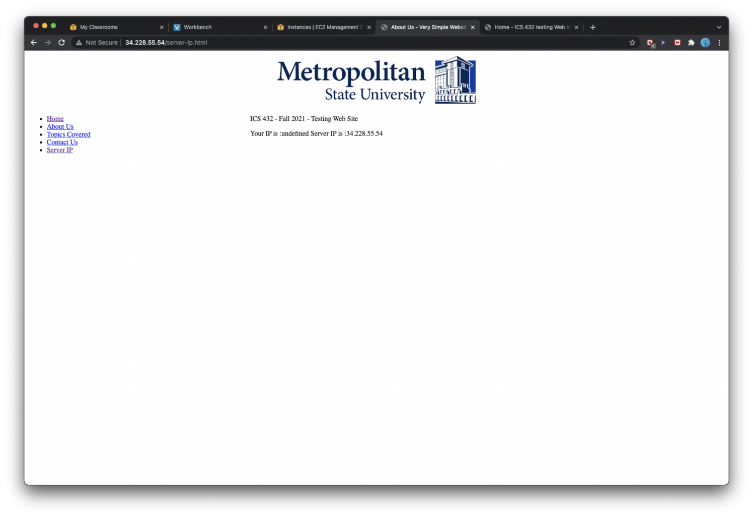

**Homework report screen-shot #8:**

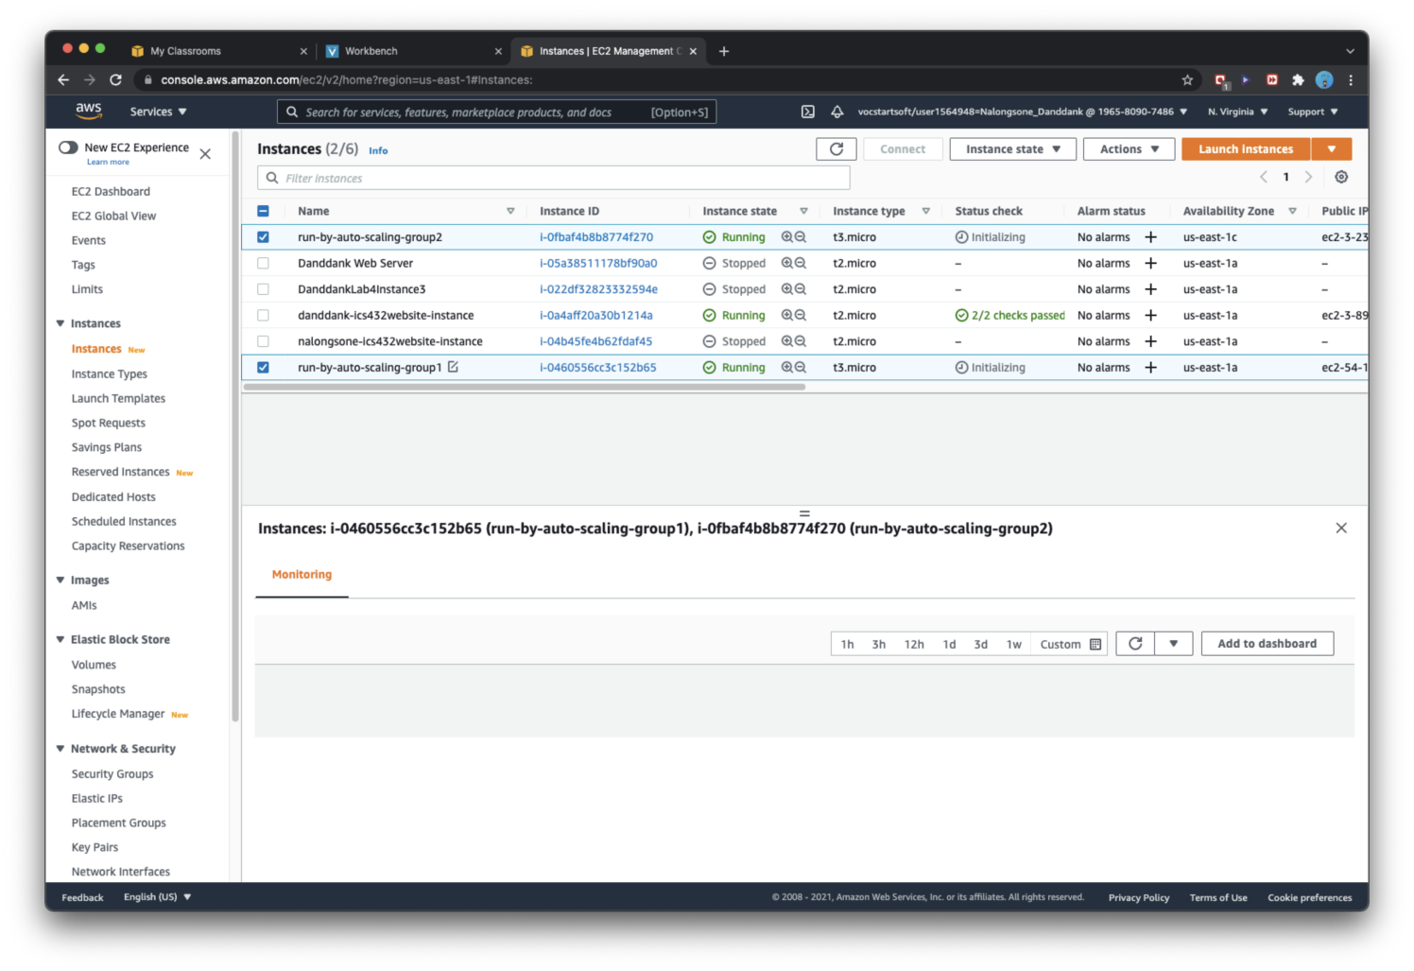

**Homework report screen-shot #9:**

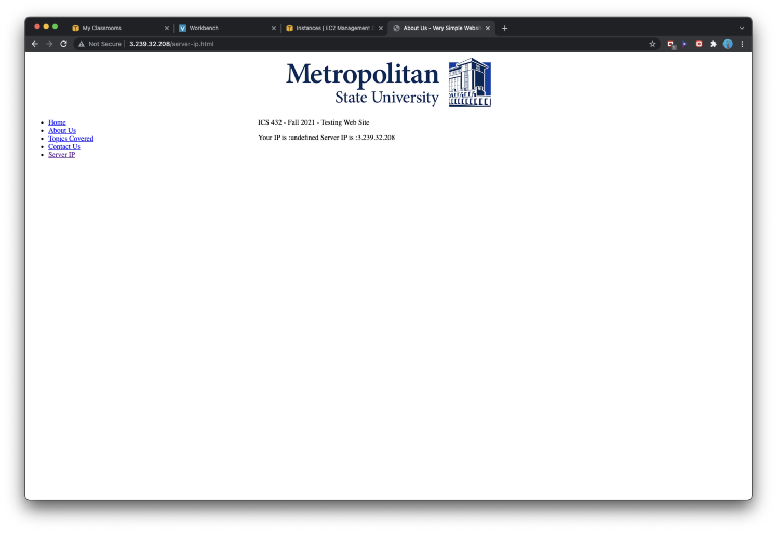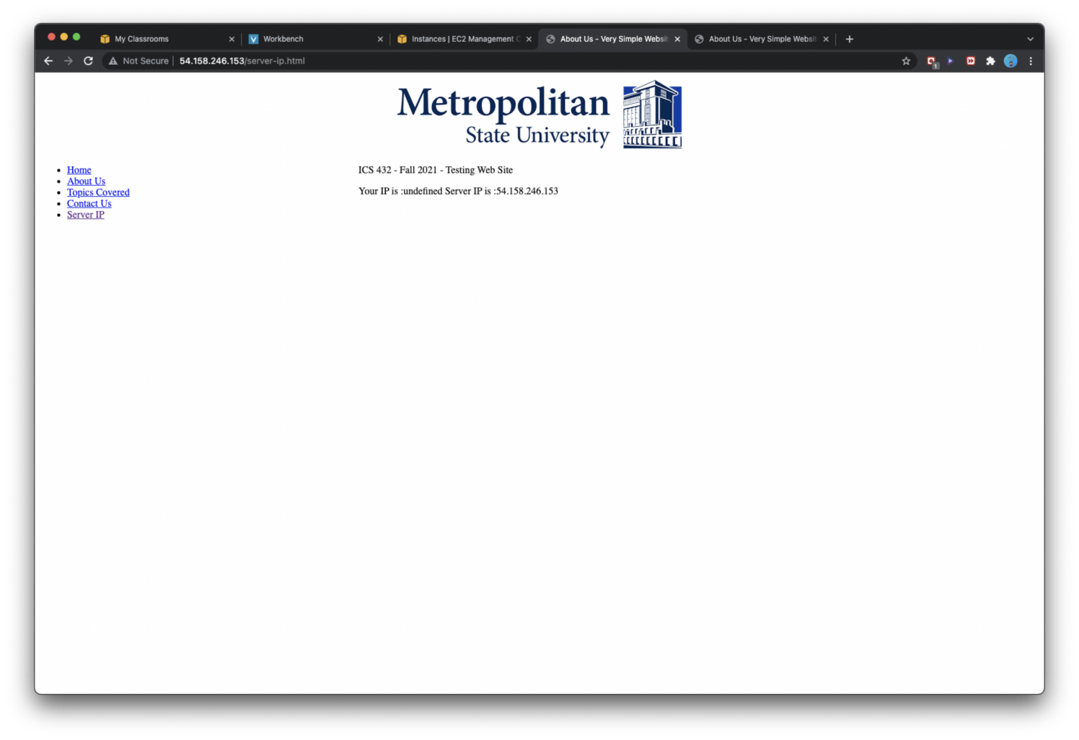

**Homework report screen-shot #10:**

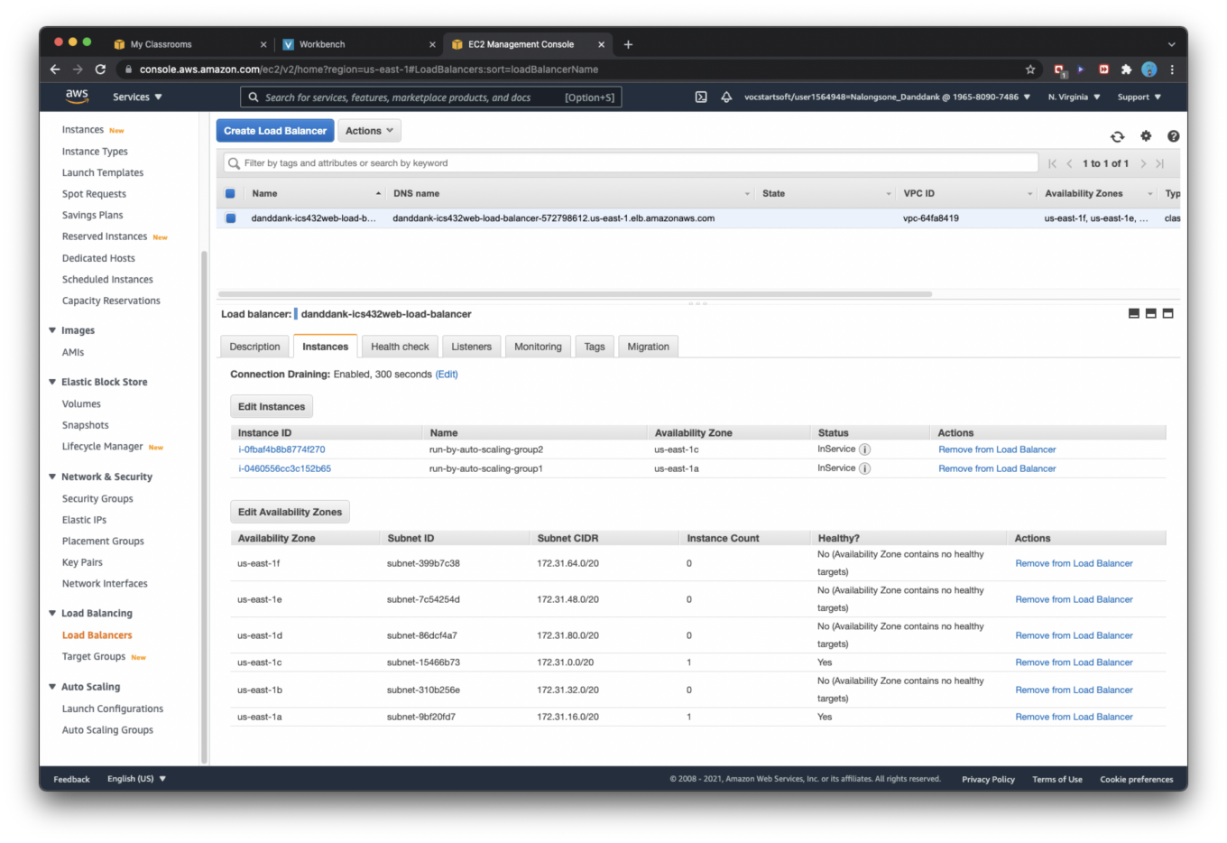

**Homework report screen-shot #11:**

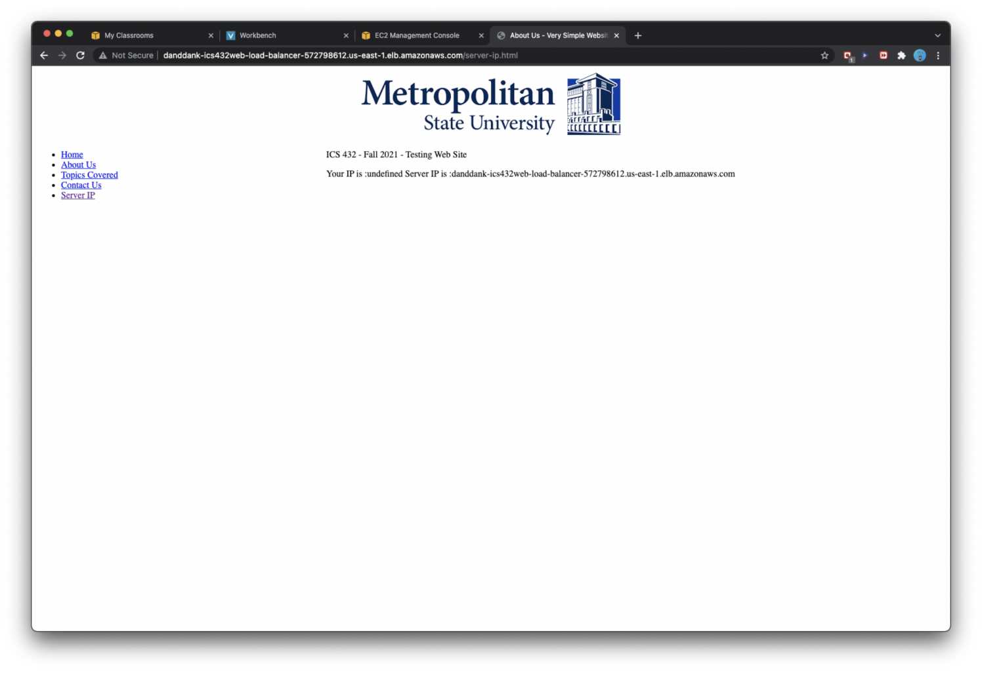





**Homework report screen-shot #12:**

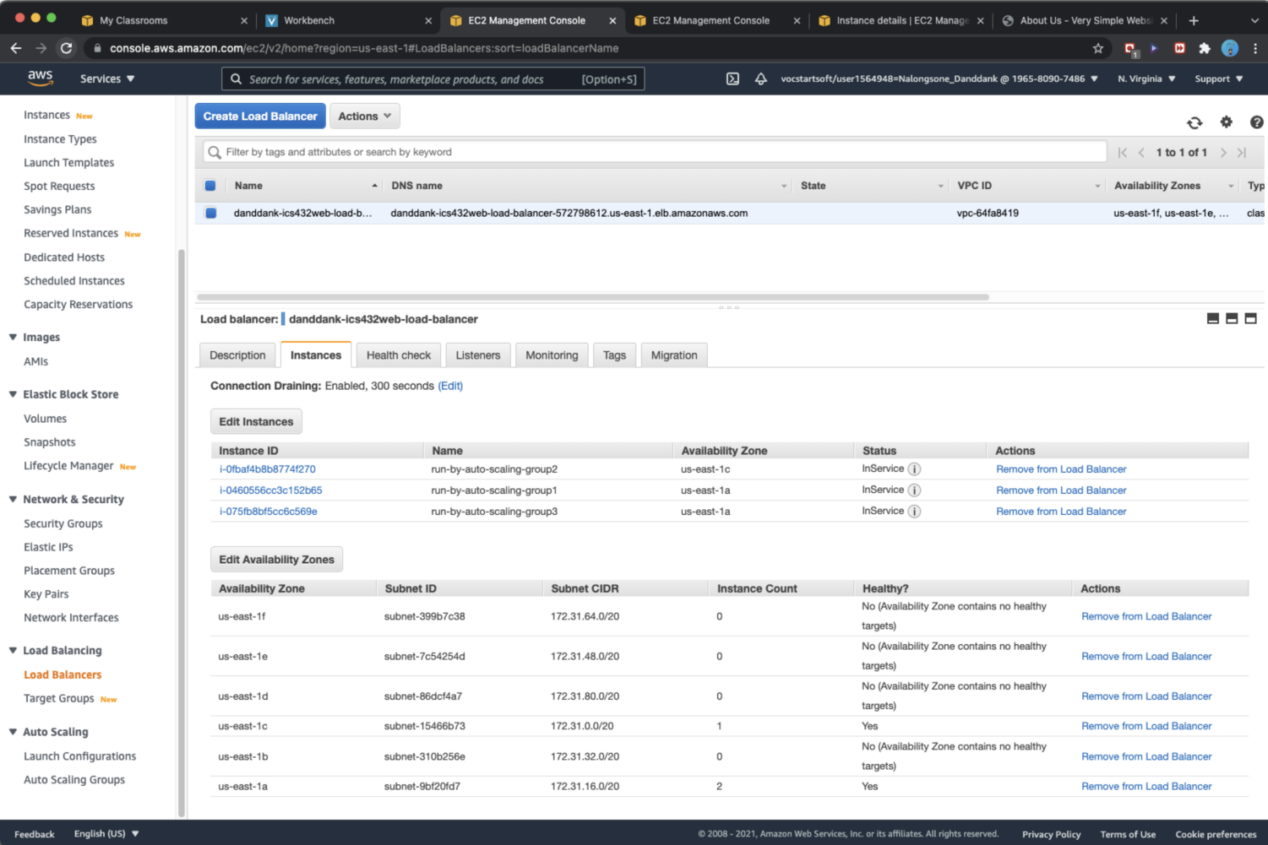

**Homework report screen-shot #13:**

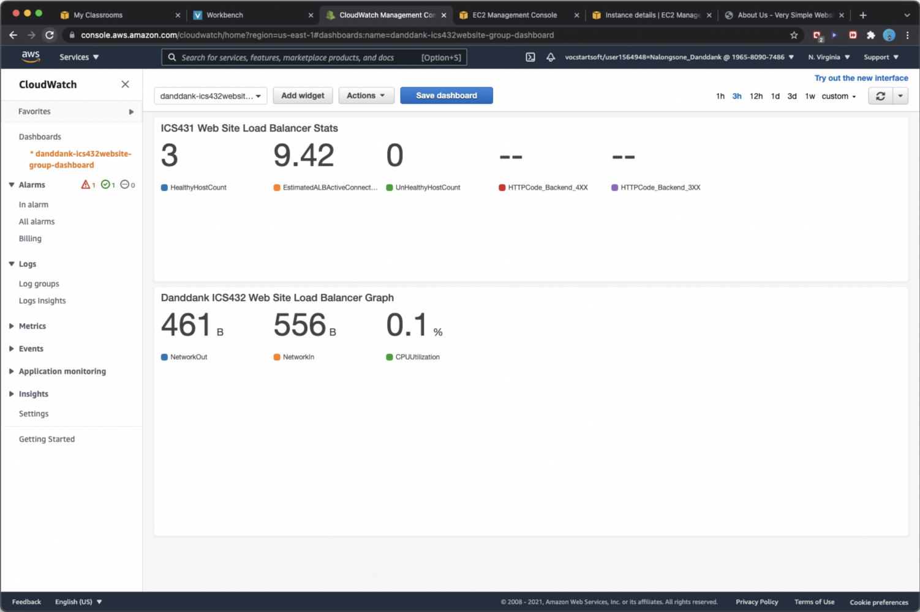

**Homework report screen-shot #14:**

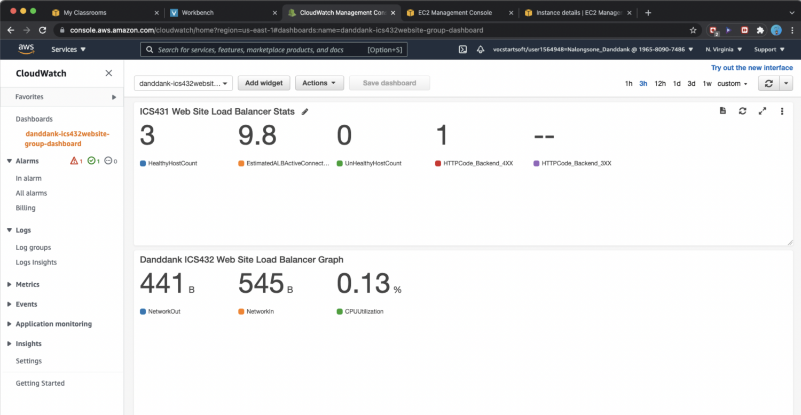

**Homework report screen-shot #15:**

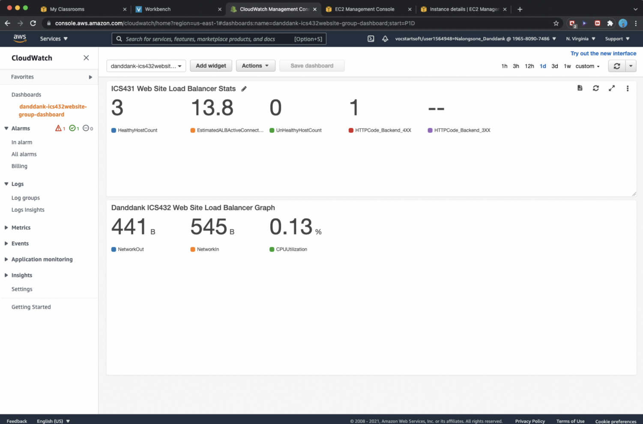

**Homework report screen-shot #16:**

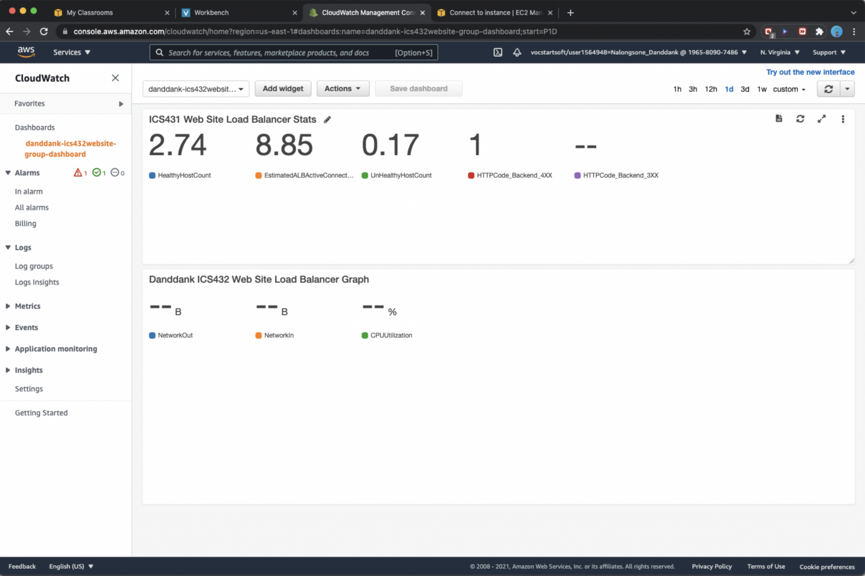

**Homework report screen-shot #17:**

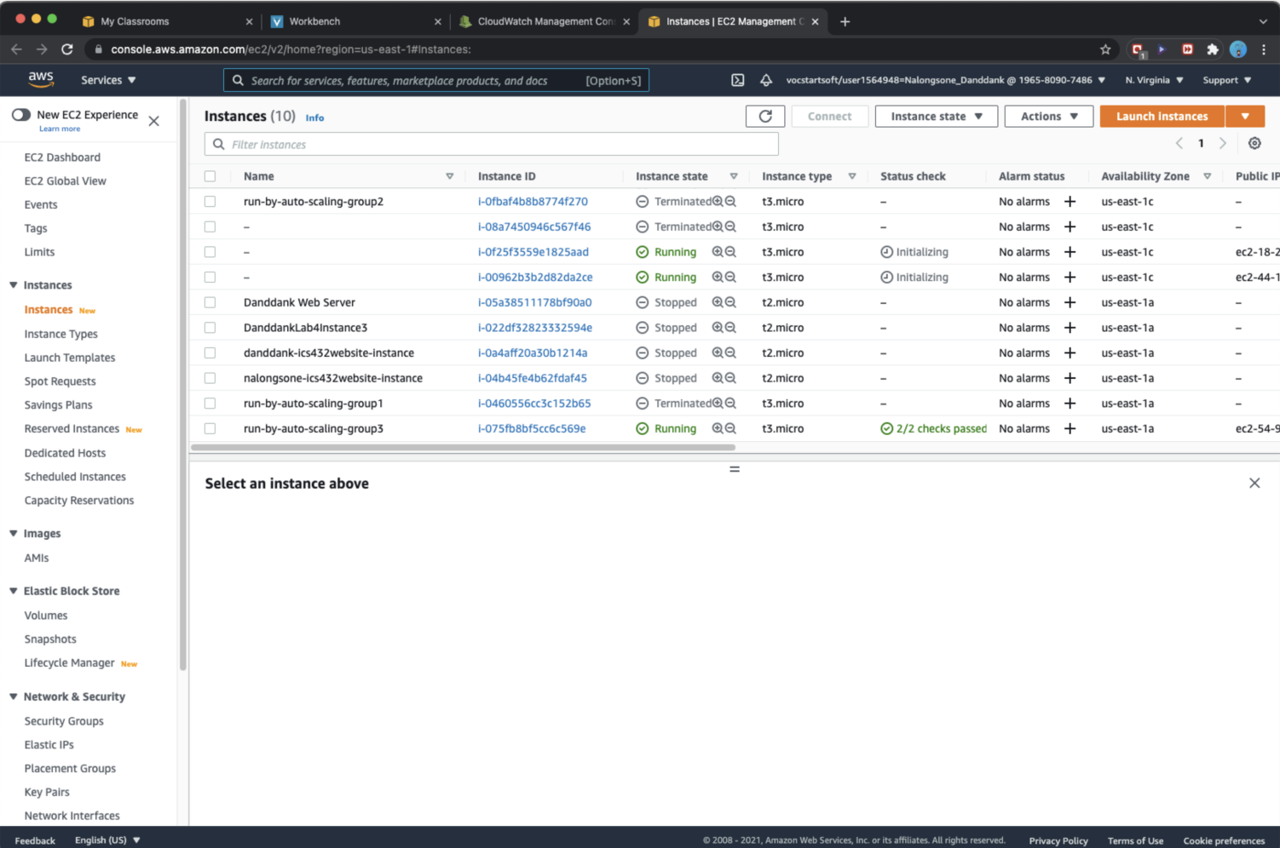

**Homework report screen-shot #18:**

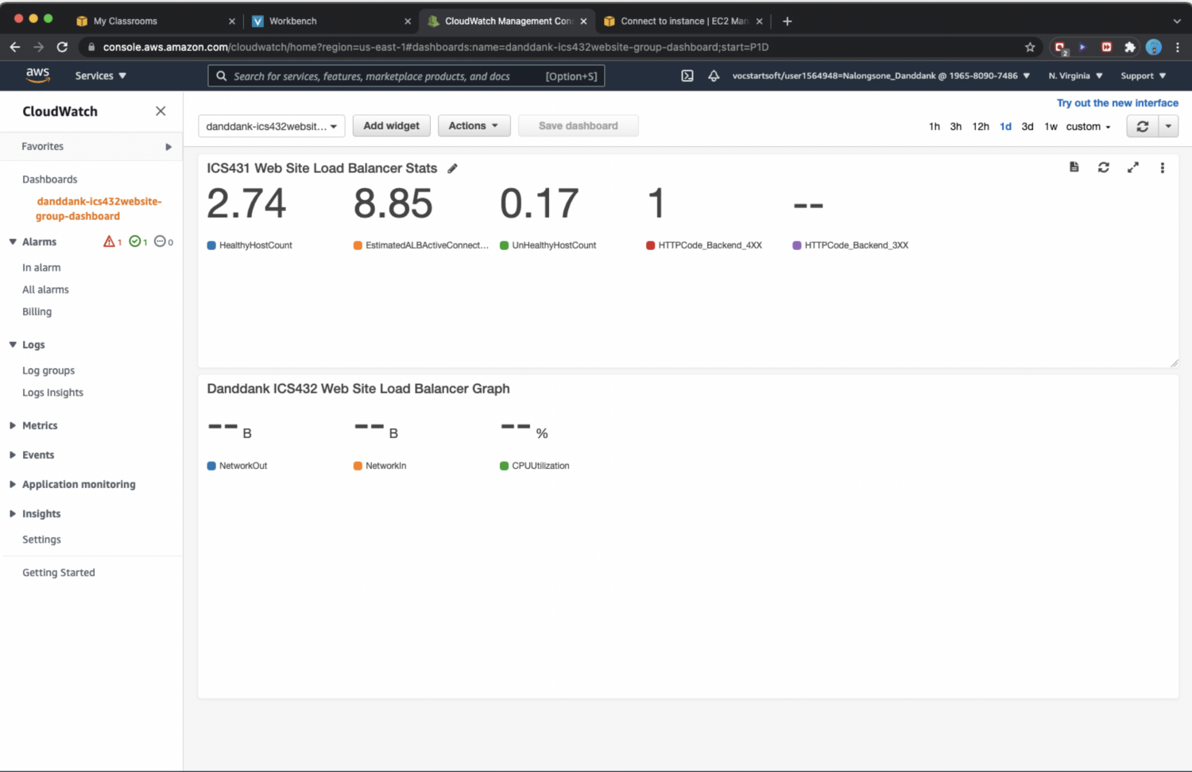

**Summarize your learning:**

I have learned to create load balance and auto scale to launch a EC2 instance of virtual machine in AWS, and learned how to deploy a web server to run in AWS in the Linux instance which I have created by auto scale group and load balance from AMIs and Instance template. then install a nginx web server software on the EC2 instance. Then, modified the security setting of the instance to allow public access for other people can access the website that I created. Finally, stop all the EC2 instance to terminate.

The most important thing is I know how to create the load balance and auto scale increase and decrease the number of instances following the requirement of traffic internet that is every significant concept of current technology and most popular use to deploy our modern website and other applications these day.

I think the most challenge me about working with the concept of how to balance the instances that created by auto scale and how to set up the parameters for them to let them to be better perform and effective. And another thing challenge me is working with the environment system, Linux, command line and system file of Linux, that is every challenge for me in the beginning to work quickly.

Exercise 2: Implementing a scalable GCP infrastructure to host a web site.

**Homework report screen-shot #19:**

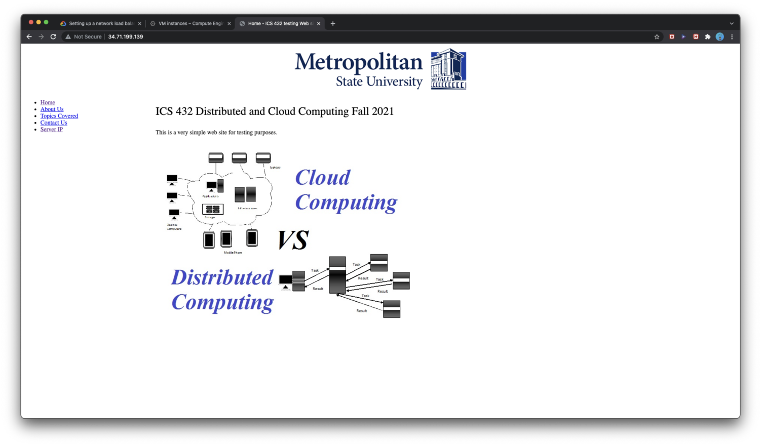

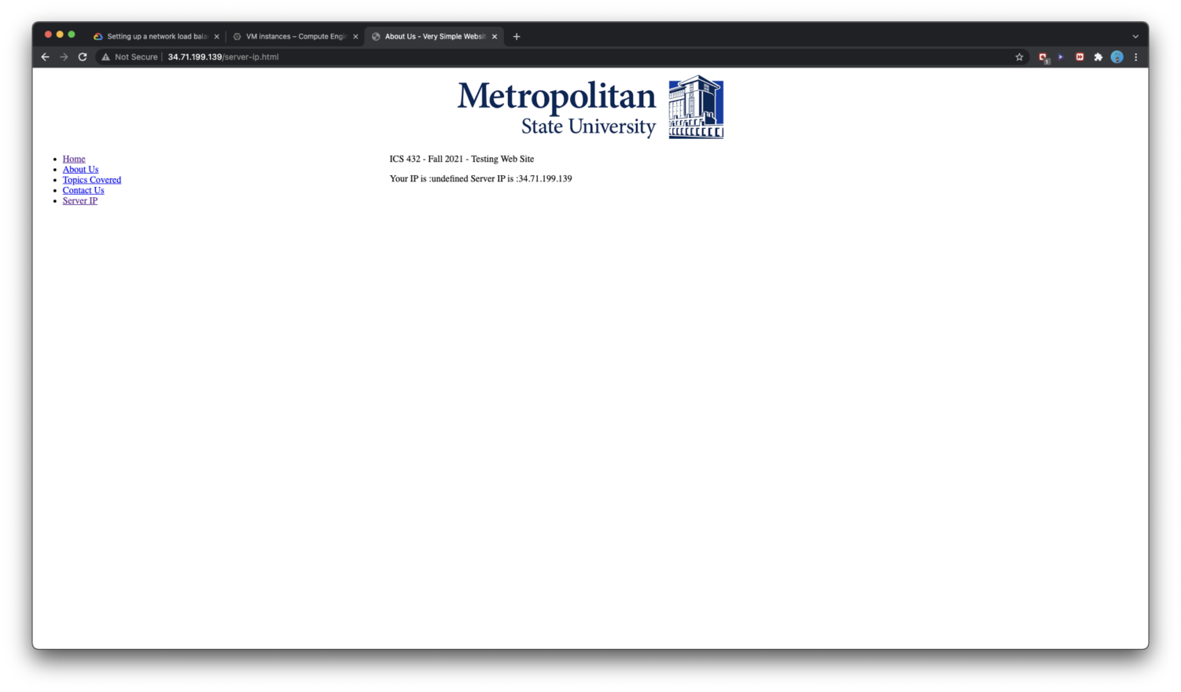

**Homework report screen-shot #20:**

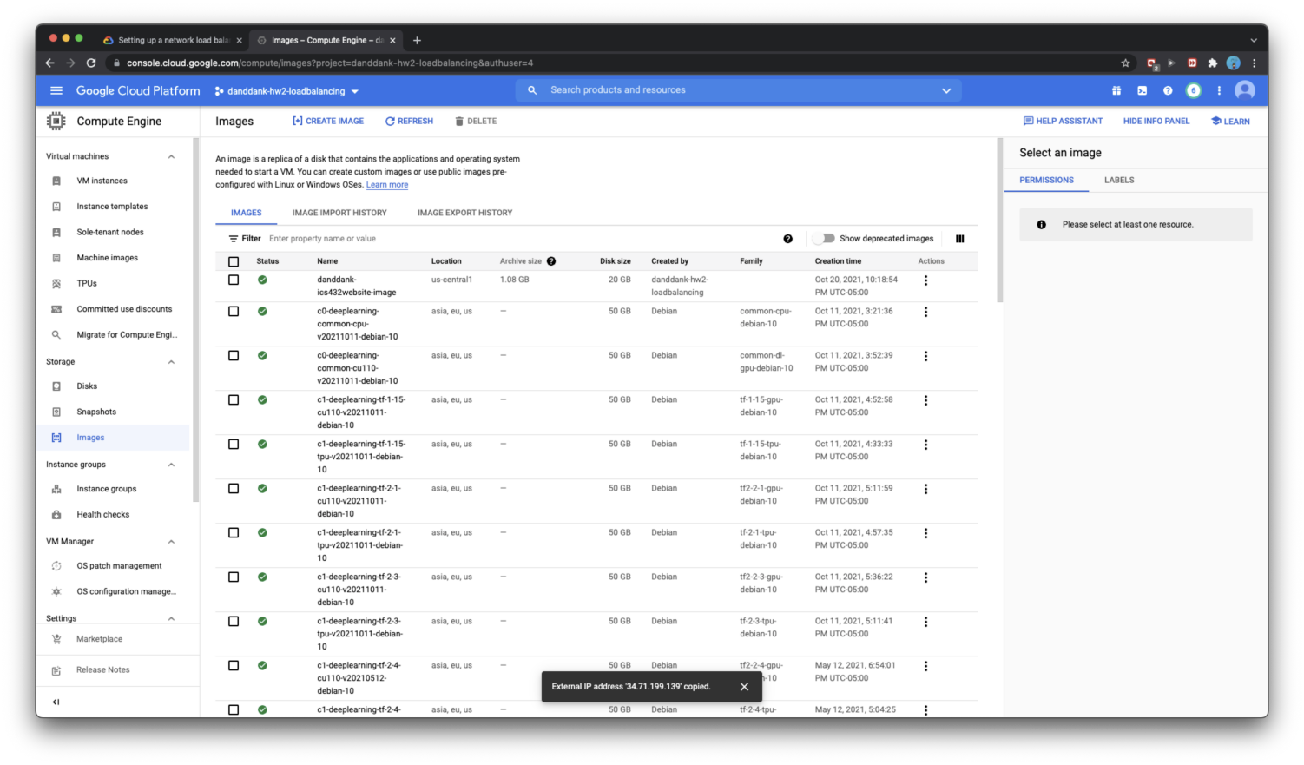

**Homework report screen-shot #21:**

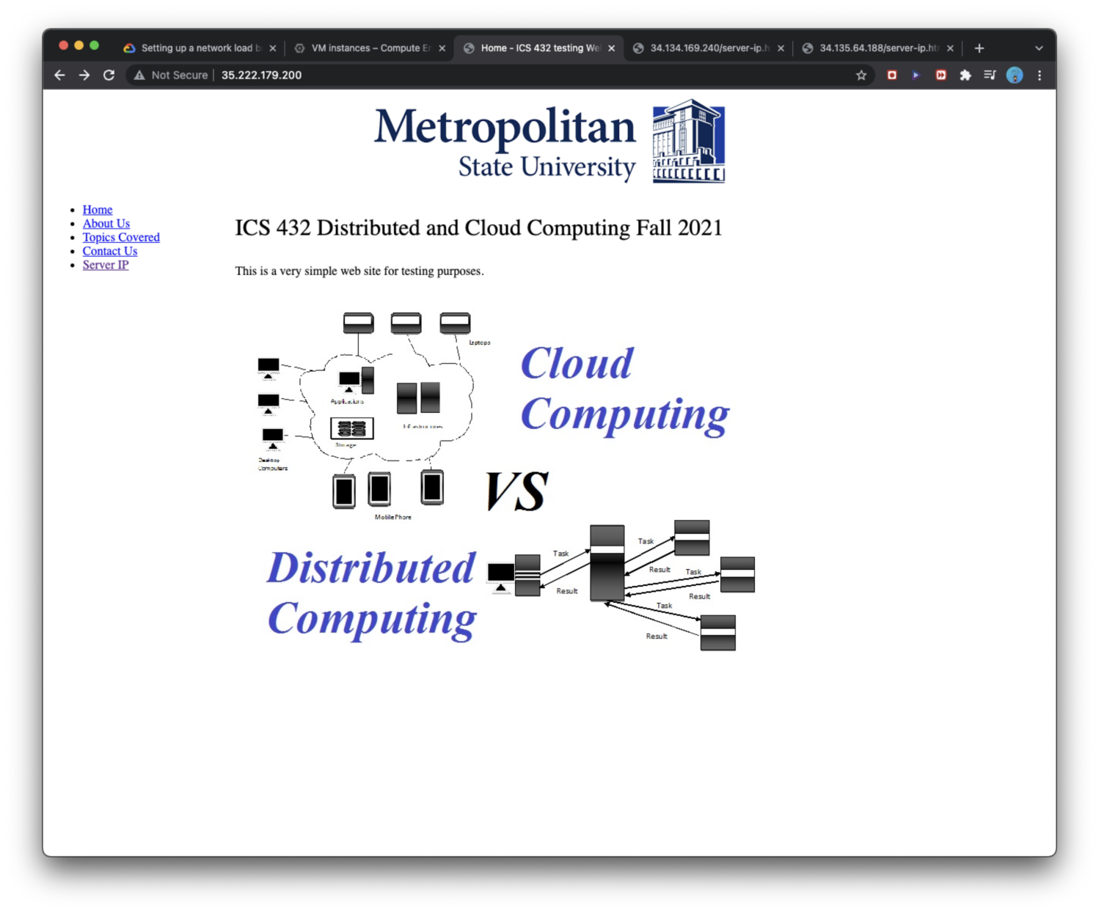

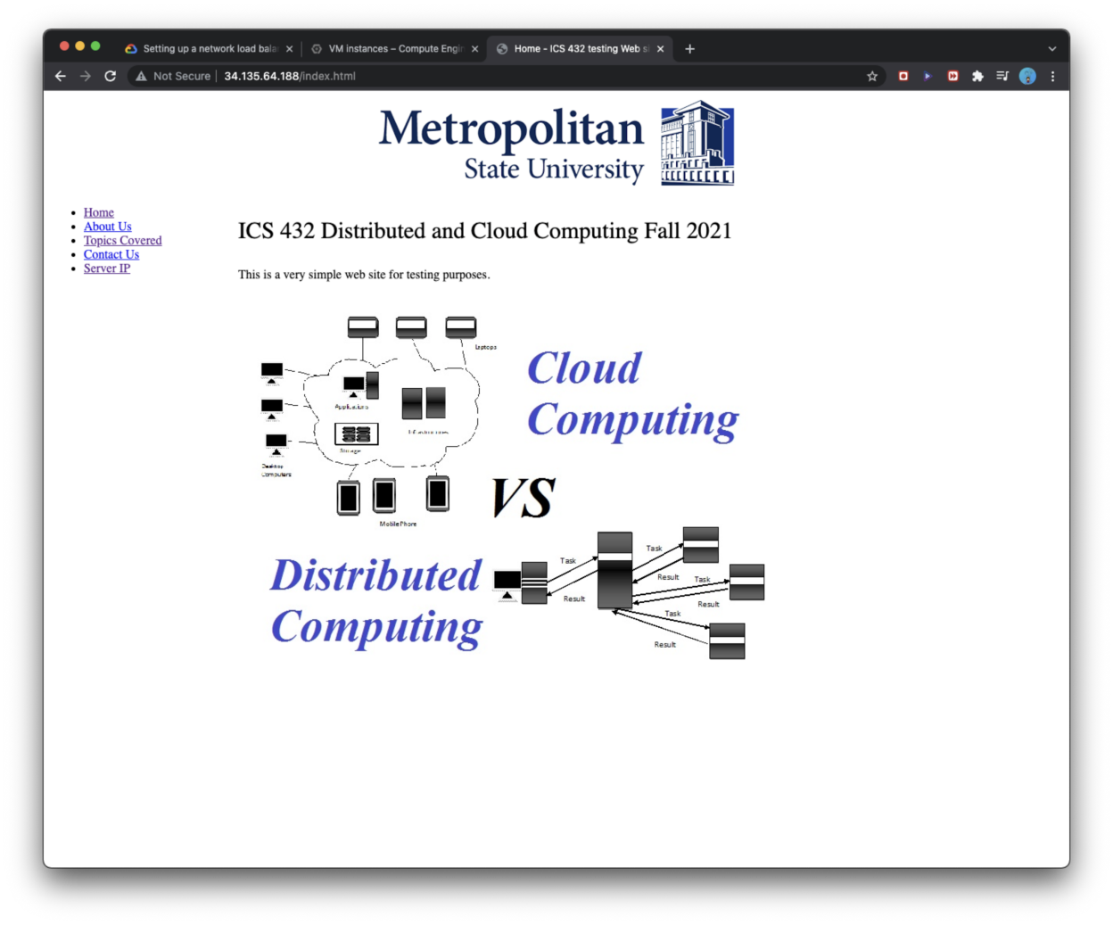

**Homework report screen-shot #22:** 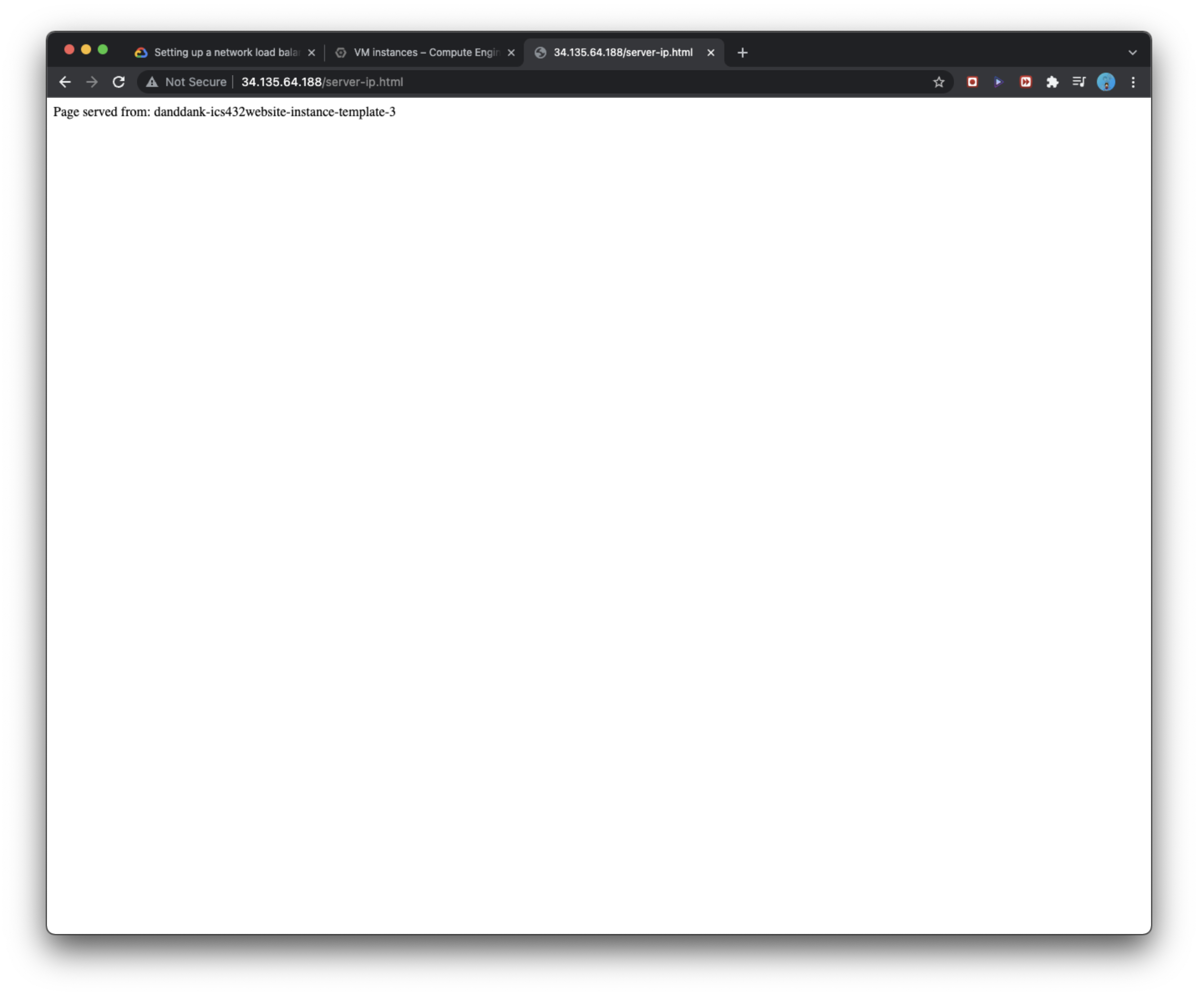

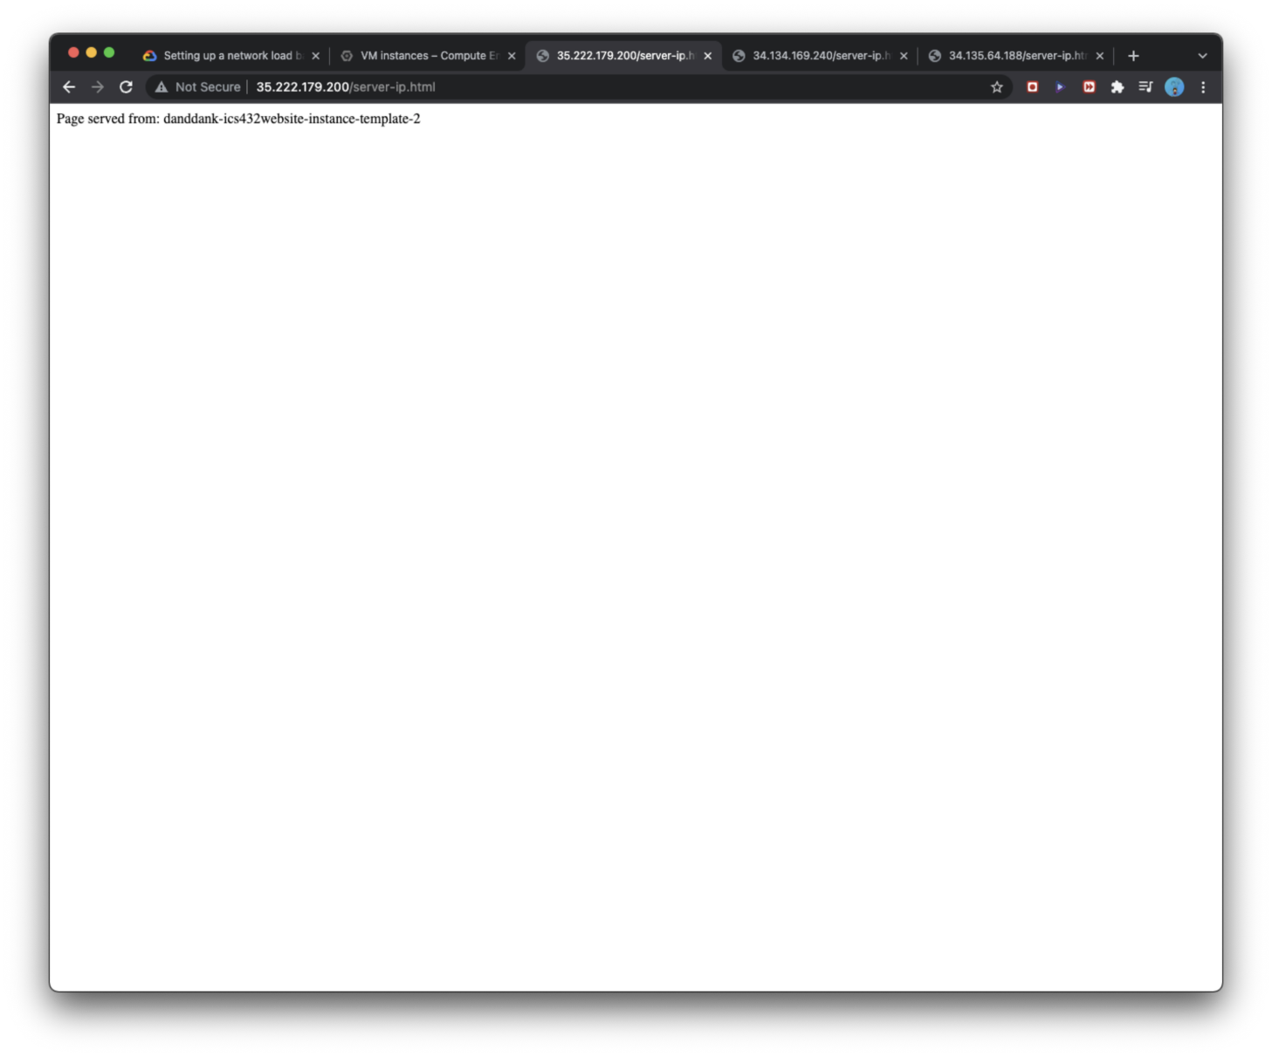

**Homework report screen-shot #23:**

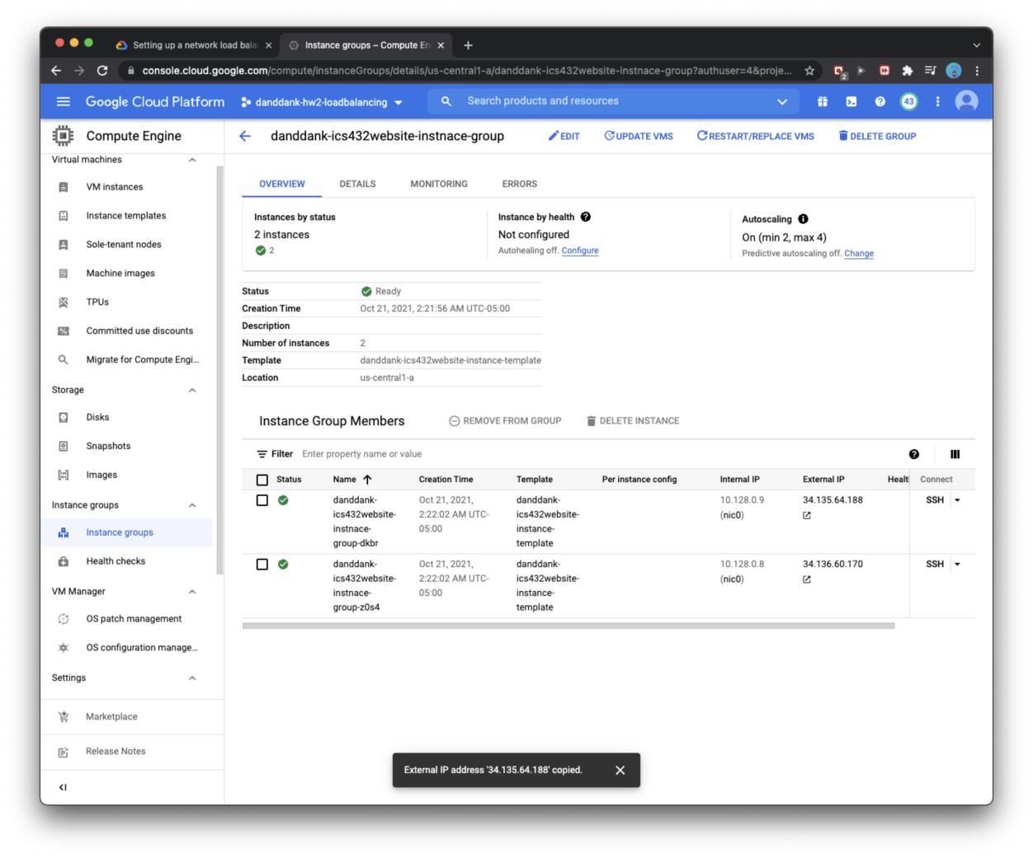

**Homework report screen-shot #24:**

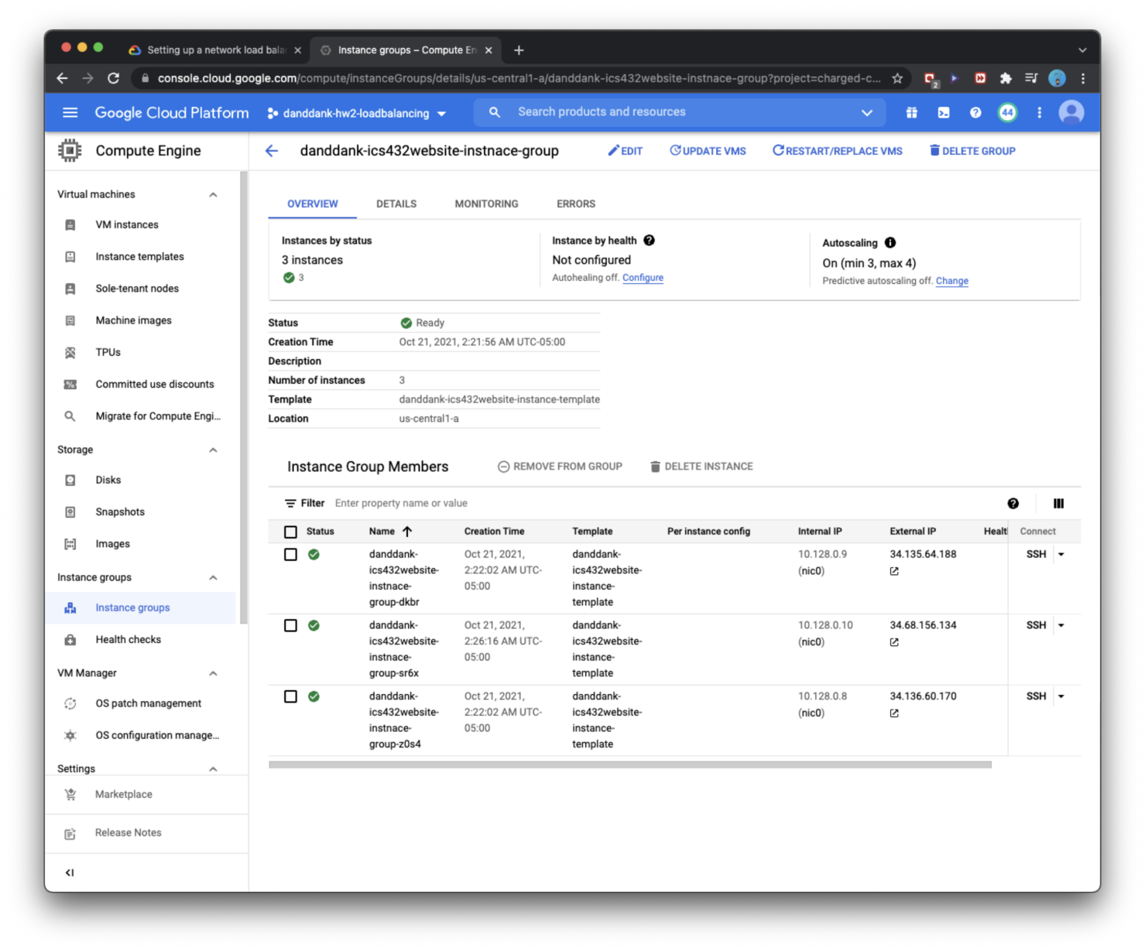

**Homework report screen-shot #25:**

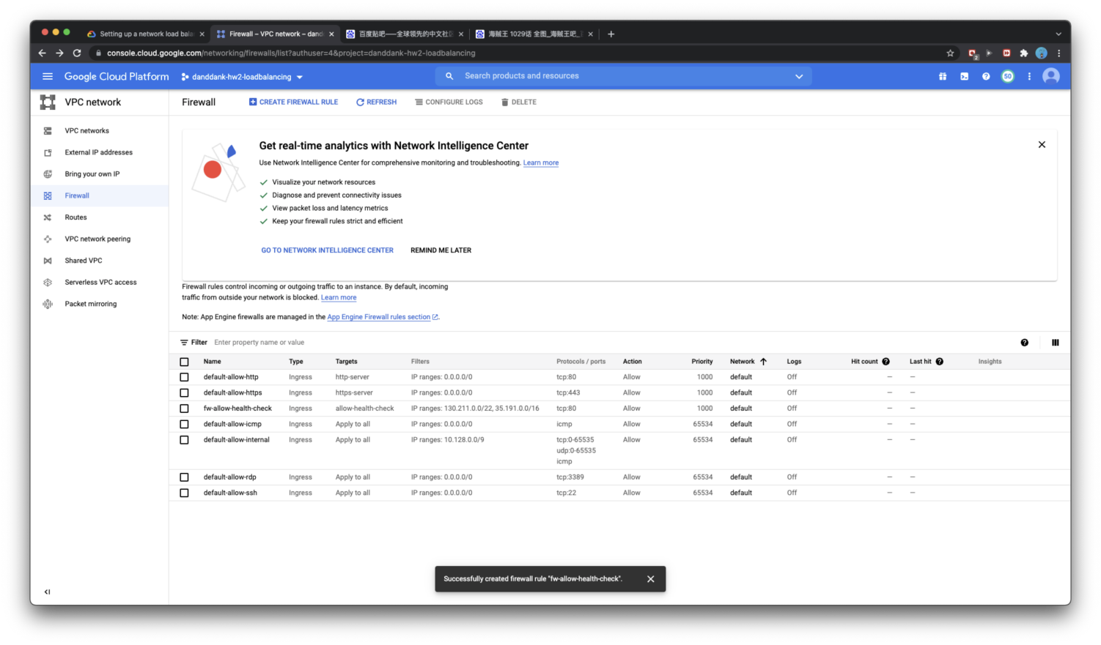

**Homework report screen-shot #26:**

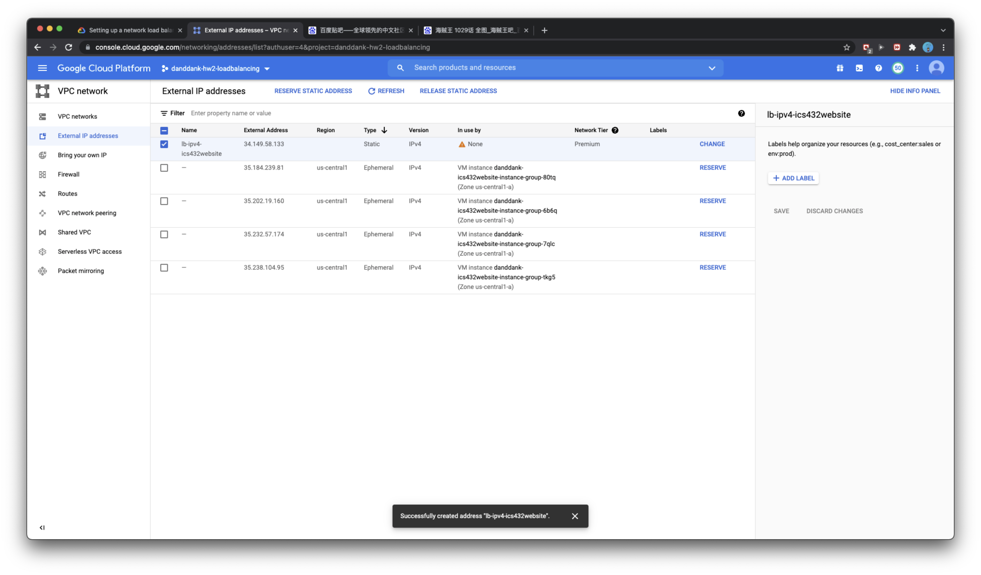

**Homework report screen-shot #27:**

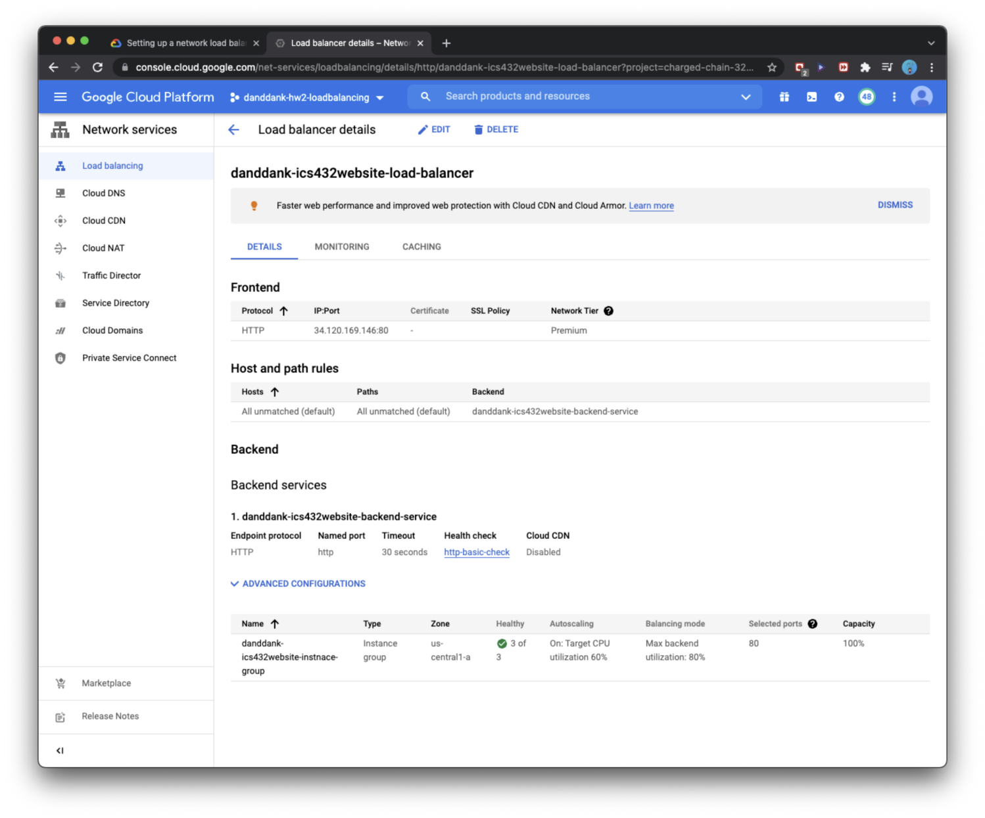

**Homework report screen-shot #28:**

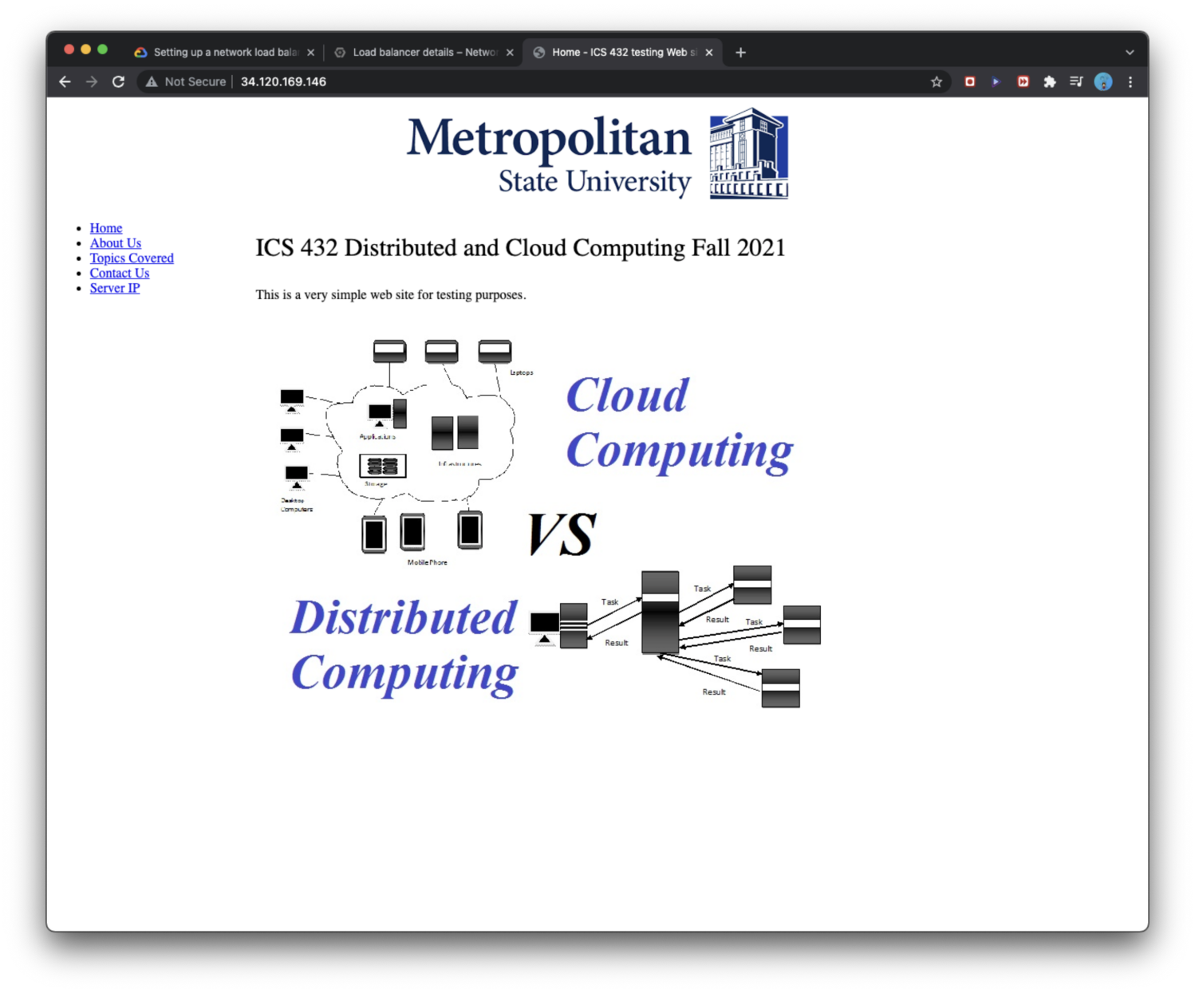

**Homework report screen-shot #29:**

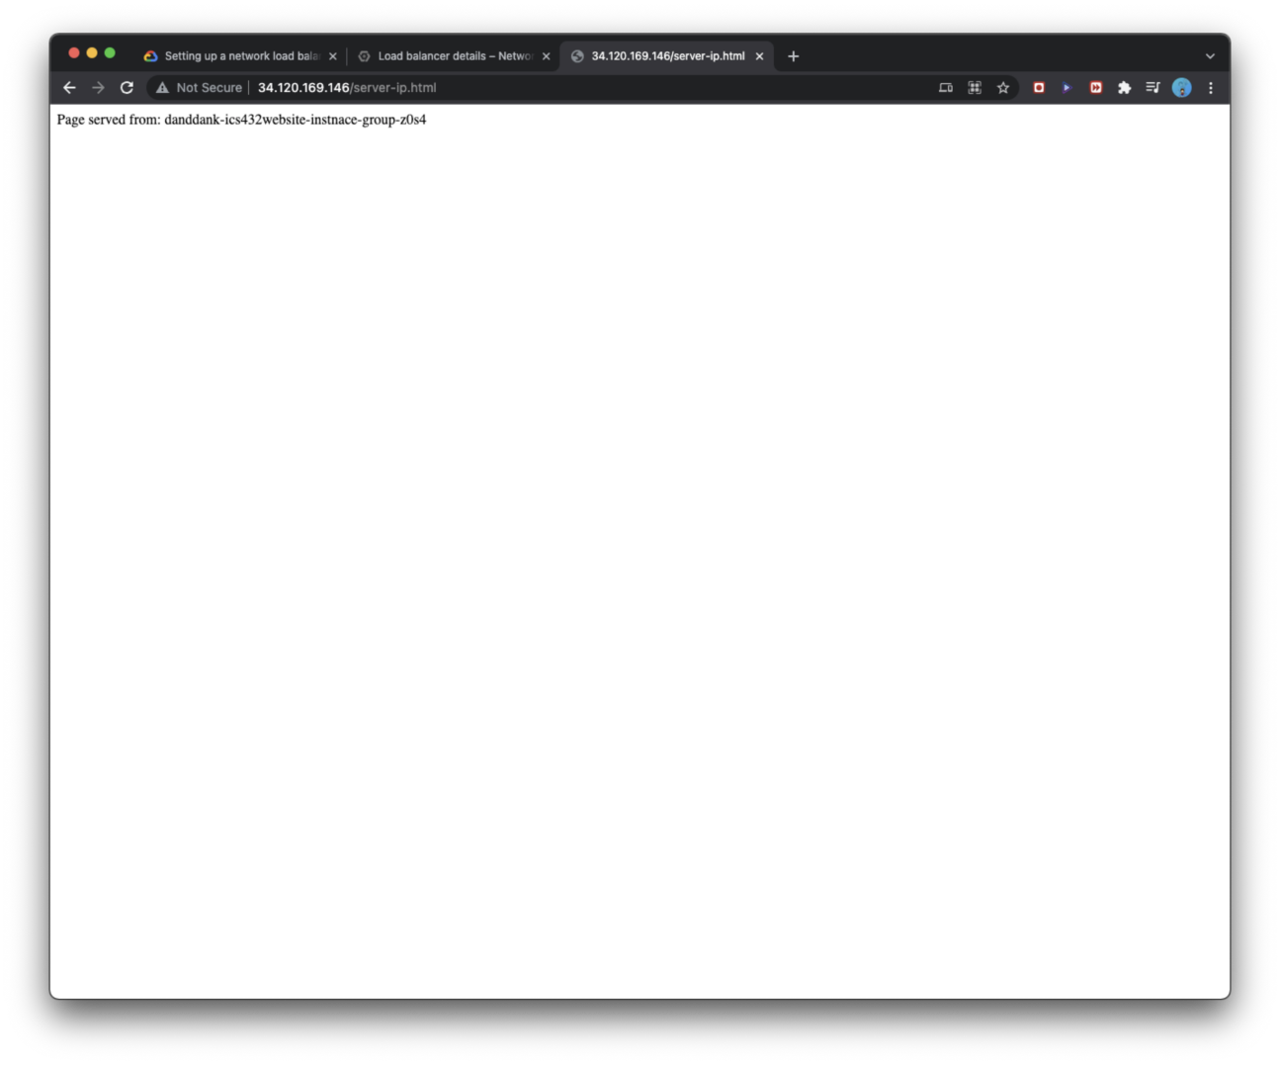

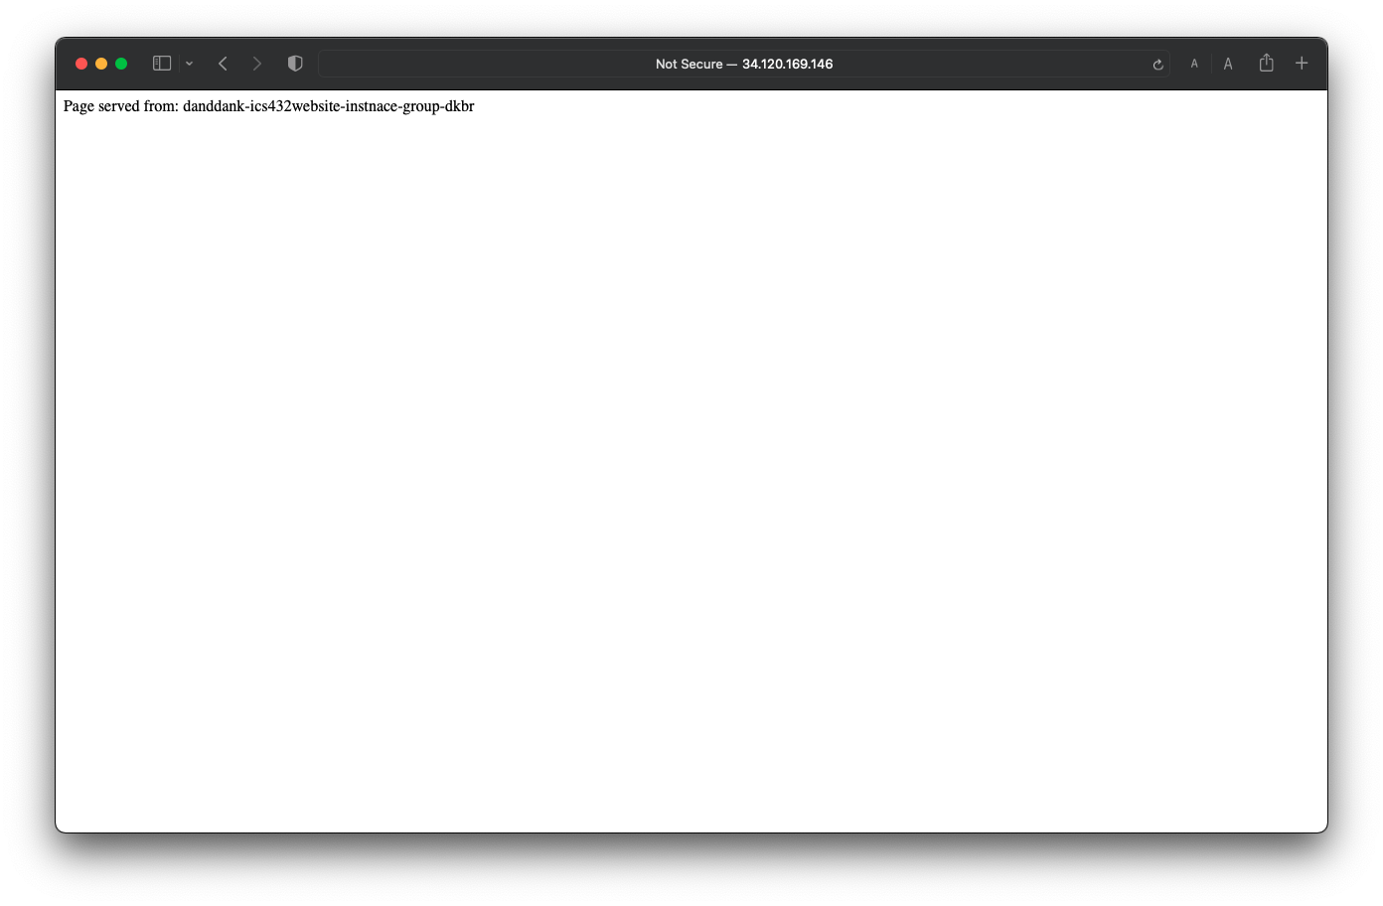

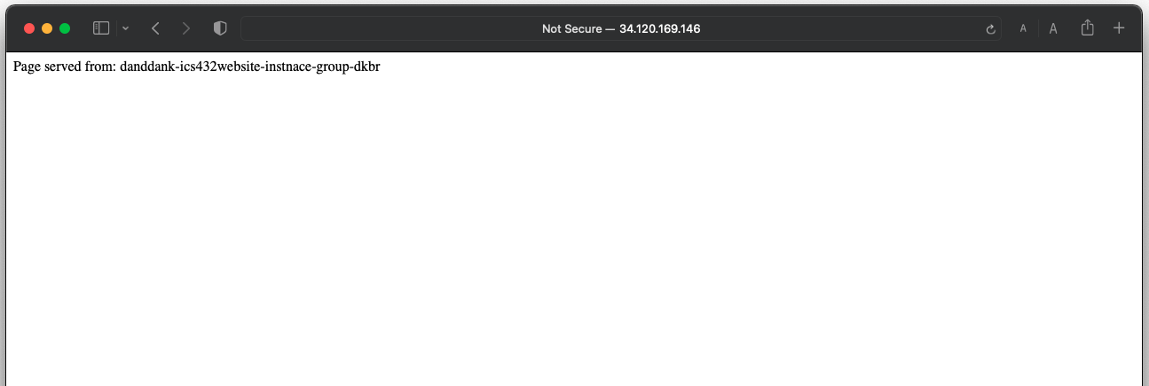

**Summarize your learning:**

I have learned to create and launch VM instance by auto scale number of instance and load balancing for web page with HTTP on server of the virtual machine of Linux which I have created. Finally, I have to stop all VM instance to terminate the cost for my account bill.

The most important thing is I have familiar with how to create VM instance GCP virtual machine, then make them auto scale by load balancing that is every significant concept of current technology and most popular use to auto scale servers.

I think the most challenge me about working with GCP’s load balance is working on the stable connection of internet to keep connect from my computer to a remote machine on GCP. And how to set up the parameters to build the load balancing for auto scale, that is every challenge for me in the beginning.

|  |  |  |
| --- | --- | --- |
| **Purpose** | **AWS** | **GCP** |
| **Running compute resources on the cloud** | **Compute -> Amazon EC2** | **Compute -> Compute Engine**  **-> VM instances** |
| **Creating Instance template** | **Compute -> Amazon EC2 -> Auto Scaling -> Launch Configurations** | **Compute -> Compute Engine**  **-> Instances templates** |
| **Create Load Balancers** | **Compute -> Amazon EC2 -> Load Balancing -> Load Balancers** | **NetWorking -> Network services -> Load Balancing** |
| **Create Security Groups** | **Compute -> Amazon EC2 -> Network & Security -> Secutity Groups** | **IAM & Admin ->** |
| **Create Instance Images** | **Compute -> Amazon EC2 -> Images -> AMIs** | **Compute -> Compute Engine**  **->Storage -> Images** |
| **Stop compute resources on the cloud** | **Compute -> Amazon EC2** | **Compute -> Compute Engine**  **-> VM instances** |
| **Building Monitoring Application Checking** | **Management & Governance -> CloudWatch** | **Oprations -> Monitoring** |